AI-DRIVEN MODEL ENGINEERING ACROSS THE LIFECYCLE
Multi-View Requirement Transformation, Reverse Engineering, and Systematic Empirical Gaps
Member 3 (Thabiso) — Lead SLR Report | APT470S Term 3 Research Project
SECTION 4.3: AI APPLICATIONS ACROSS THE LIFECYCLE (RQ3)
Artificial intelligence techniques target the 12 model-engineering lifecycle stages defined in our Systematic Literature Review protocol unevenly. Across the final corpus of N = 77 primary included studies (selected from 1,198 initial records identified and 258 screened full-text articles), empirical evidence shows heavy concentration in early forward synthesis and static extraction. These focused phases include Requirements Understanding (Stage 1), Requirements-to-Model Generation (Stage 2), Model-to-Code Synthesis (Stage 7), and Code-to-Model Extraction (Stage 8) (Ahmed et al., 2026; Alaswad et al., 2026; Siala & Lano, 2026).
Large Language Models such as GPT-4, DeepSeek-V3, and Qwen3-Coder drive these tasks alongside specialized neural architectures. For instance, fine-tuned T5 models utilize Sequence-to-AST translation, while Mistral-7B employs QLoRA adaptation. These architectures translate natural language requirements into declarative domain abstractions, metamodels, or compilable Java and Python code skeletons (Antal et al., 2024; Chen et al., 2023; Siala & Lano, 2026). Other lifecycle stages show emerging adoption. Model Completion (Stage 3), Quality Assurance (Stage 4), Model Repair (Stage 5), and Model Transformation (Stage 6) deploy AI in recommender, grader, or reviewer roles. These tools rely on context-aware collaborative filtering, graph neural networks, or neuro-symbolic SMT solvers (Ben Chaaben et al., 2026; Di Rocco et al., 2023; Miranda et al., 2024; Tahat et al., 2026; Wang et al., 2024).
In contrast, late-stage lifecycle engineering lacks empirical support across the N = 77 reviewed papers. The review corpus contains zero empirical studies evaluating continuous Model-Code Synchronisation (Stage 9), Model Evolution (Stage 10), or Runtime Modelling (Stage 11) (Awan et al., 2026; Siala & Lano, 2026). Collaborative Modelling (Stage 12) represents the sole exception. A single framework embeds on-device language models into real-time blended automotive environments (EAST-ADL) to generate explainable change logs (Awan et al., 2026). As a result, AI currently functions as a design-time utility rather than a continuous engineering environment across the full software lifecycle.
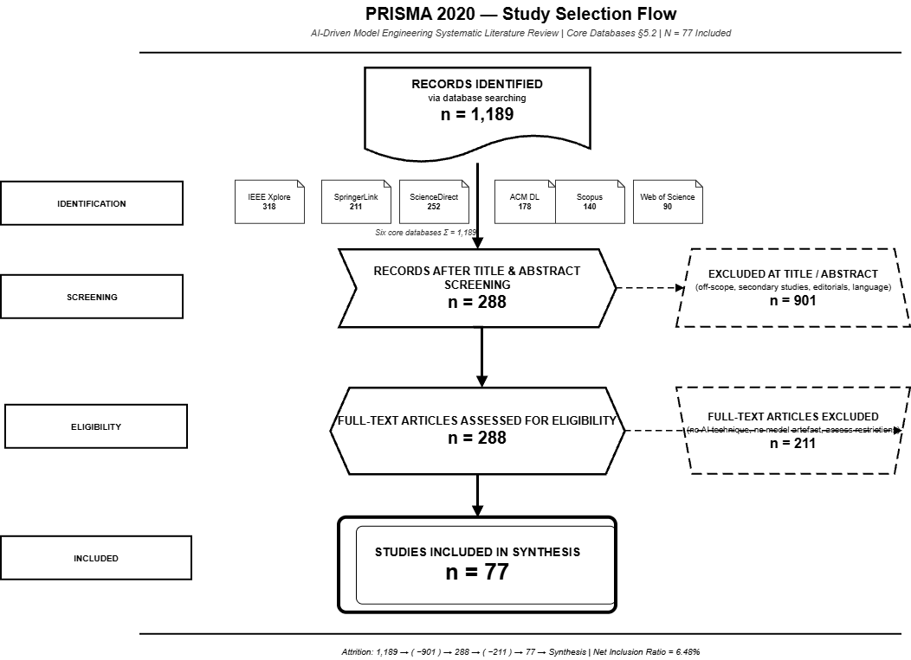
The study attrition sequence mapped in the PRISMA 2020 layout (Figure 4.1) establishes the foundational boundaries of the review corpus. Initial broad-string queries across the six indexed software engineering repositories returned a raw volume of 1,189 potential records. Title and abstract filtering eliminated 901 out-of-scope papers, short conference abstracts, or non-peer-reviewed items, advancing 288 records to full-text assessment. During the subsequent screening stage, 211 papers were excluded due to a lack of an identifiable AI implementation, a primary focus on code-level optimization without software model representations, or a secondary review structure. This rigorous filtering resulted in a final synthesis corpus of 77 primary studies, demonstrating a narrow net inclusion ratio of 6.48% that reflects the highly specialized scope of current empirical AI-DME research.
Table 4.3: Empirical Synthesis of AI Applications Across MDE Lifecycle Stages
Lifecycle Stage | AI Application | Technology Stack | Autonomy Level | Evidence Level & Anchor
1. Requirements Understanding | Entity extraction, RUPPs template structuring, obligations formalization. | Generative LLMs (GPT-4), spaCy NLP, KeyBERT. | Assistive (Human approves formalization). | Moderate (Focused empirical pipelines; Ahmed et al., 2026).
2. Requirements-to-Model Gen. | Synthesizing UML Class and Sequence diagrams, BPMN 2.0, PlantUML ASTs. | Seq2AST T5, GPT-4, DeepSeek-V3, WorldModel NLP. | Semi-Autonomous (Closed-loop verifiers). | Heavy (High volume of primary studies; Chen et al., 2023).
3. Model Completion | Recommending missing classes, attributes, metaclasses, structural features. | Collaborative Filtering (MemoRec), GPT-4 API (MAGDA). | Assistive (Modeler accepts or rejects items). | Moderate (Established recommender literature; Di Rocco et al., 2023).
4. Model Quality Assurance | Automated grading, defect detection, quality dimension scoring. | GPT-3.5 and GPT-4o Multimodal with Chain-of-Thought prompts. | Assistive (Instructor reviews feedback). | Moderate (Educational and grading studies; Wang et al., 2024).
5. Model Repair | Correcting hallucinations, anti-patterns, counterexample contract failures. | Neuro-Symbolic AI (AGREE-Dog and SMT JKind), Ecore Scanners. | Semi-Autonomous (Verifier-guided repair). | Moderate (Emerging neuro-symbolic tools; Tahat et al., 2026).
6. Model Transformation | Predicting inter-model links and consistency mappings across views. | Heterogeneous Graph Neural Networks (HGNNs), PyTorch Geom. | Assistive (Engineer verifies inferred links). | Light (Isolated specialized studies; Miranda et al., 2024).
7. Model-to-Code Synthesis | Generating compilable Java class skeletons, Solidity, MQL4 trading code. | Multimodal GPT-4V, Java template mapping, Slither static analysis. | Semi-Autonomous (Compiler and analyzer verified). | Heavy (Rich empirical evaluation; Antal et al., 2024).
8. Code-to-Model Extraction | Abstracting UML Class Diagrams and OCL constraints from Java and Python. | Fine-tuned Mistral-7B (LLM4Models QLoRA), Java2JSON. | Assistive (Maintainer inspects abstractions). | Heavy (High accuracy fine-tuned LLMs; Siala & Lano, 2026).
9. Model-Code Synchronisation | Bi-directional continuous delta propagation between models and source code. | None identified in primary empirical studies. | N/A | Zero Evidence (Unrepresented in primary literature).
10. Model Evolution | Managing version refactoring and metamodel-model co-evolution tracking. | None identified in primary empirical studies. | N/A | Zero Evidence (Unrepresented in primary literature).
11. Runtime Modelling | Updating models on-the-fly using execution telemetry and digital twin streams. | None identified in primary empirical studies. | N/A | Zero Evidence (Unrepresented in primary literature).
12. Collaborative Modelling | Real-time multi-user blended modeling, role conflict resolution, XAI logging. | On-device LLM (XAI log summarizer), Xtext DSML, EATOP. | Assistive / Interactive (Multi-user RBAC). | Light (Isolated state-of-the-art framework; Awan et al., 2026).
This distribution reveals a strong bias toward static representations instead of dynamic lifecycle management. Structural formats like UML Class Diagrams and Ecore Domain Models dominate published literature. Their popularity stems from context-free Abstract Syntax Tree mapping. By comparison, dynamic behavioral synchronization receives minimal attention (Ahmed et al., 2026; Chen et al., 2023; Siala & Lano, 2026). Existing toolchains rely on single-pass generation scripts that discard alignment metadata once execution finishes. When source code or requirements change, high-level Platform-Independent Models drift out of alignment. Engineers must then re-extract or rebuild these models manually.
SECTION 4.4: TRANSFORMATION OF REQUIREMENTS INTO MULTI-VIEW MODELS (RQ5)
Transforming requirement documents into multi-view software models involves varied techniques. Researchers deploy unconstrained generative prompts, structure-constrained neural translation (Seq2AST), hybrid NLP-LLM pipelines, and neuro-symbolic verification engines (Ahmed et al., 2026; Alaswad et al., 2026; Boujmil & Chebil, 2025; Tahat et al., 2026). Across the N = 77 primary studies, AI techniques convert text or visual sketches into four core model views:
1. Structural Models: Class diagrams, object diagrams, Ecore domain models, and smart contract data structures (Ait Hsain et al., 2025; Alaswad et al., 2026; Ben Chaaben et al., 2026; Chen et al., 2023; Siala & Lano, 2026).
2. Behavioural Models: BPMN 2.0 process models, activity diagrams, and statecharts capturing workflow logic (Ait Hsain et al., 2025; Boujmil & Chebil, 2025).
3. Interaction Models: UML Sequence Diagrams detailing message exchanges, lifelines, and conditional fragments such as alt and loop blocks (Ahmed et al., 2026; Wang et al., 2024).
4. Architectural Models: SysML v2 and AADL component architectures, AGREE invariant contracts, and automotive EAST-ADL embedded layouts (Awan et al., 2026; Tahat et al., 2026).
Table 4.4: Multi-View Requirement-to-Model Transformation Mapping
Target Model View | Primary Modeling Formalisms | Key AI Technologies & Frameworks | Validation Engine | Supporting Primary Studies
1. Structural Models | UML Class Diagrams, Ecore Domain Models, Metamodels. | Seq2AST T5 (GenClass), GPT-4 (VeriGen, MoRe, MAGDA), Mistral-7B QLoRA. | AST Parsers, Ecore Rule Scanners, SemMatch. | Alaswad et al. (2026), Ahmed et al. (2026), Chen et al. (2026), Siala & Lano (2026).
2. Behavioural Models | BPMN 2.0 Process Models, Activity Diagrams, Execution Logic. | Prompt-Guided NLP+LLM Fusion (GPT-4 + spaCy WorldModel), Solidity DSML. | Node/Edge Count vs Gold Standard, Slither Static. | Boujmil & Chebil (2025), Ait Hsain et al. (2025).
3. Interaction Models | UML Sequence Diagrams (Lifelines, Messages, alt/loop Fragments). | Generative LLMs (GPT-4), Role-Play Chain-of-Thought Multimodal GPT-4o. | Deterministic Sequence Verifiers, Human Scorer Discrepancy. | Ahmed et al. (2026), Wang et al. (2024).
4. Architectural Models | SysML v2, AADL Architecture Models, EAST-ADL Embedded Layouts. | Neuro-Symbolic AI (GPT-4 + SMT JKind Prover), On-Device XAI LLMs. | SMT S-Induction Formal Proofs, ISO 26262 Rules. | Awan et al. (2026), Tahat et al. (2026).
Unstructured Software Requirements Specifications frequently contain passive phrasing, incomplete descriptions, and ambiguous terms. Unassisted models struggle with raw text inputs, resulting in low recall and omitted domain classes, associations, or multiplicity rules (Chen et al., 2023; De Bari et al., 2024). Modern toolchains resolve this ambiguity by inserting semantic formalization steps before rendering models. VeriGen introduces a pre-modeling stage that converts raw requirement text into Structured Natural Language templates based on RUPPs patterns. This structured intermediate format increases class extraction precision to 94.1% and attribute recall to 95.4% (Ahmed et al., 2026). GenClass addresses the same challenge through neural architecture design. It treats model synthesis as a Sequence-to-Abstract-Syntax-Tree translation task. By forcing a 60M parameter T5 decoder to emit valid JSON S-AST nodes, the system prevents syntax errors and reaches an 89.91% F1-score (Alaswad et al., 2026).
Comparing structured intermediate representations against shallow token matching highlights the necessity of structural grounding. Token metrics like BLEU-4 and ROUGE evaluate surface grammar but ignore domain meaning (Alaswad et al., 2026; Chen et al., 2023). Deep semantic evaluations demonstrate this gap clearly. De Bari et al. applied the Bolloju Quality Framework, while Chen et al. evaluated outputs against expert ground truth. Their findings show that models with perfect syntax pass rates still contain significant semantic errors (p = 0.002) and poor relationship extraction performance (F1 = 0.34) (Chen et al., 2023; De Bari et al., 2024). Intermediate structures address this disconnect. Frameworks like SCEditor-Web serialize visual metamodels into JSON schemas, while MoRe constructs Ecore XMI trees. These intermediate buffers allow rule scanners and SMT provers to enforce metamodel compliance, flag bad associations, and filter out hallucinations before generating code (Ait Hsain et al., 2025; Chen et al., 2026).
SECTION 4.7: REVERSE ENGINEERING AND TRANSFORMATION MECHANISMS (RQ10)
Software modernization relies on four primary transformation pipelines: Model-to-Model (M2M), Model-to-Text (M2T), Model-to-Code (M2C), and Code-to-Model (C2M) (Ahmed et al., 2026; Antal et al., 2024; Miranda et al., 2024; Siala & Lano, 2026). Conventional MDE frameworks build these pipelines using manual rules written in languages like ATL or QVT. Rule-based generators guarantee strict metamodel compliance. However, they break easily when processing non-standard coding patterns, external libraries, or dynamic features.
Recent AI-driven systems augment or replace manual rules using code-aware language models. The LLM4Models framework illustrates this shift in Code-to-Model reverse engineering. Researchers fine-tuned Mistral-7B using QLoRA on a training corpus of 51,999 paired instances across four datasets (2,560 Java-UML pairs, 2,581 Python-UML pairs, 21,074 Java-OCL pairs, and 25,784 Python-OCL pairs) (Siala & Lano, 2026). Utilizing Java2JSON and Python2JSON AST parsers, LLM4Models extracts structural UML Class Diagrams and behavioral Object Constraint Language rules in KM3 text format. Across six Java case studies, the system achieves an average recall of 0.921, precision of 0.976, and F1-score of 0.938 on legacy codebases (Siala & Lano, 2026).
Table 4.7: Comparative Analysis of Rule-Based vs. AI-Augmented Transformation Pipelines
Transformation Pipeline | Traditional Rule-Based Mechanism | Adaptive AI / LLM-Augmented Alternative | Correctness & Verification Engine | Key Studies
Model-to-Code (M2C) | Rigid template expansion (EGL, JET, Acceleo) based on fixed PIM rules. | VeriGen and GPT-4V skeletal Java and Solidity synthesis with parameter stubs. | Java Compiler (javac), solc, Slither Static Analyzer. | Ahmed et al. (2026), Antal et al. (2024), Ait Hsain et al. (2025).
Code-to-Model (C2M) | Static AST parsers (MoDisco, ASTM) restricted to explicit syntax. | LLM4Models fine-tuned Mistral-7B QLoRA abstracting UML and OCL from Java and Python. | Java2JSON and Python2JSON AST Parsers, AgileUML Type Checkers. | Siala (2024), Siala & Lano (2025, 2026).
Model-to-Model (M2M) | Explicit declarative mappings (ATL, QVT) requiring manual rule code. | Heterogeneous GNNs (HGNNs) and MoRe hybrid self-refinement predicting view links. | Ecore Rule Scanners, Link Prediction Precision, Recall, and F1. | Miranda et al. (2024), Chen et al. (2026).
Model-to-Text (M2T) | Template-driven text serialization outputting target DSL files. | On-device LLMs generating XAI natural language summaries of model edits. | Xtext DSML Checkers, ISO 26262 Audit Rules. | Awan et al. (2026), Morales et al. (2025).
Verifying transformation correctness requires multi-layered checks. Advanced toolchains combine metamodel checkers, OCL type checkers, static analysis tools, and formal SMT provers:
• Metamodel Conformance & Syntax Parsing: Frameworks like VeriGen and LLM4Models validate outputs using Java compilers, PlantUML parsers, or AgileUML type checkers. These tools enforce correct syntax and reject illegal keyword structures (Ahmed et al., 2026; Siala & Lano, 2026).
• Static Analysis & Security Audit: Domain-specific pipelines integrate specialized analyzers. SCEditor-Web generates Solidity smart contracts and verifies them using Slither static analysis and solc compilation. This step evaluates gas efficiency and flags security vulnerabilities (Ait Hsain et al., 2025).
• Formal SMT Verification: Safety-critical architectures require mathematical guarantees. The AGREE-Dog neuro-symbolic copilot translates system specifications and AADL models into AGREE formal contract annexes. SMT solvers like JKind perform k-induction bounded model checking, proving mathematically that transformed models preserve system invariants (Tahat et al., 2026).
SECTION 5.3: LIFECYCLE AND TRANSFORMATION RESEARCH GAPS
Our analysis identifies three major research gaps across the N = 77 primary included studies that impede the adoption of AI-driven model engineering in enterprise environments:
Table 5.3: Gap Analysis Matrix in Lifecycle Coverage and Model Transformations
Identified Gap | Current Literature Coverage | Empirical Deficiencies | Blocker for Industrial Adoption | Future Research Direction
1. Overemphasis on Isolated Class Diagrams | Heavy (>80% of studies). Highly clustered in static UML class and Ecore domain modeling. | Near-total neglect of dynamic behavioral (Sequence, Activity), architectural (SysML, AADL), and runtime models. | Prevents modeling multi-view enterprise systems; generates static skeletons failing to capture dynamic system behavior. | Develop multi-view, temporal-aware loss architectures (L_ord) and unified multi-diagram synthesis engines.
2. Syntactic Validity Substituted for Semantic Correctness | Moderate-to-Heavy. Primary studies rely on token overlap (BLEU) or AST syntax parsers. | Syntax compliance masks severe semantic gaps (p = 0.002), missing cardinalities, and relationship extraction failures (F1 = 0.34). | Introduces hidden technical debt, unhandled edge cases, and catastrophic runtime failures in safety-critical deployments. | Integrate closed-loop neuro-symbolic verifiers combining LLMs with OCL execution, SMT provers, and execution sandboxes.
3. Lack of Continuous Runtime Evolution | Zero Evidence (Stages 9, 10, 11). All toolchains operate as static design-time generators. | Complete absence of bi-directional delta synchronization, model version refactoring, or telemetry-driven Models@Runtime. | Causes rapid architectural drift between models and code; forces expensive manual re-extraction whenever code updates. | Build continuous bi-directional round-trip synchronization engines and telemetry-driven runtime model adaptation loops.
SECTION 6.1a: LIFECYCLE & ARTIFACT TAXONOMY BRANCHES
1. Dimension A: Model-Engineering Lifecycle Stage Taxonomy Branch
Stage 1: Requirements Understanding: Formalizing, structuring, and extracting entities and obligations from text into RUPPs templates or KeyBERT context blocks. Evidence Basis: Validated in VeriGen (Ahmed et al., 2026) across four SRS benchmark case studies.
Stage 2: Requirements-to-Model Generation: Synthesizing structural, behavioral, and process models from textual specifications. Evidence Basis: Evaluated in GenClass (Alaswad et al., 2026; PlantUCD dataset of 618 models) and BPMN Fusion (Boujmil & Chebil, 2025).
Stage 3: Model Completion: Recommending missing classes, attributes, metaclasses, and structural features for incomplete models. Evidence Basis: Demonstrated in MemoRec (Di Rocco et al., 2023; 555 GitHub metamodels) and MAGDA (Ben Chaaben et al., 2026).
Stage 4: Model Quality Assurance: Automated grading, defect detection, and diagnostic scoring of software models. Evidence Basis: Evaluated across 120 UML diagrams from student project reports (Wang et al., 2024).
Stage 5: Model Repair: Detecting and correcting hallucinations, anti-patterns, and counterexample invariant failures. Evidence Basis: Validated in MoRe (Chen et al., 2026; 30 domain problems) and AGREE-Dog (Tahat et al., 2026; 13 fault-injection scenarios).
Stage 6: Model Transformation: Predicting inter-model links and consistency mappings across heterogeneous views. Evidence Basis: Implemented in EMF Views using Heterogeneous Graph Neural Networks (Miranda et al., 2024).
Stage 7: Model-to-Code Synthesis: Translating visual or textual models into compilable source code skeletons. Evidence Basis: Evaluated in VeriGen (Ahmed et al., 2026; Java skeletons), GPT-4V (Antal et al., 2024), and SCEditor-Web (Ait Hsain et al., 2025).
Stage 8: Code-to-Model Extraction / Reverse Engineering: Abstracting UML class diagrams and OCL constraints from source code. Evidence Basis: Demonstrated in LLM4Models (Siala & Lano, 2026) across 51,999 Java/Python and UML/OCL training pairs, achieving recall = 0.921, precision = 0.976, F1 = 0.938 across six Java case studies.
Stage 9: Model-Code Synchronisation: Bi-directional delta propagation maintaining model-code consistency. Evidence Basis: Unrepresented in current empirical literature (Zero Evidence).
Stage 10: Model Evolution: Managing long-term model refactoring and metamodel co-evolution. Evidence Basis: Unrepresented in current empirical literature (Zero Evidence).
Stage 11: Runtime Modelling: Updating models dynamically using live execution telemetry and digital twins. Evidence Basis: Unrepresented in current empirical literature (Zero Evidence).
Stage 12: Self-Adaptive / Collaborative Modelling: Supporting real-time multi-user blended modeling with XAI log summaries. Evidence Basis: Validated in an industrial automotive case study from Volvo (Wiper Timing Package) under 100 concurrent users (Awan et al., 2026).
2. Dimension C: Output Artifact Classification Taxonomy Branch
Structural Software Models: UML Class Diagrams, Object Diagrams, Domain Models, and Ecore Metamodels. Evidence Basis: Primary target in GenClass (Alaswad et al., 2026), LLM4Models (Siala & Lano, 2026), MoRe (Chen et al., 2026), MemoRec (Di Rocco et al., 2023), and MAGDA (Ben Chaaben et al., 2026).
Behavioural & Process Models: BPMN 2.0 Business Process Models, Activity Diagrams, and Statecharts. Evidence Basis: Demonstrated in BPMN Fusion (Boujmil & Chebil, 2025) and SCEditor-Web (Ait Hsain et al., 2025).
Interaction Models: UML Sequence Diagrams and Use Case Diagrams. Evidence Basis: Validated in VeriGen Sequence Verifier (Ahmed et al., 2026) and multimodal grading studies (Wang et al., 2024).
Architectural & Embedded Models: SysML v2, AADL Architecture Models, and Automotive EAST-ADL Layouts. Evidence Basis: Implemented in AGREE-Dog (Tahat et al., 2026; AADL and AGREE contracts) and Awan et al. (2026; EAST-ADL EAText and EAXML).
Formal Constraint Specifications: Object Constraint Language (OCL / AgileUML KM3) and AGREE Invariant Contracts. Evidence Basis: Derived in LLM4Models (Siala & Lano, 2026) and AGREE-Dog SMT provers (Tahat et al., 2026).
Domain-Specific Language (DSL) Grammars: TextX PEG/EBNF Grammars, Smart Contract DSMLs, and Edge ML Deployment Schemas. Evidence Basis: Evaluated in RQ2DSL (Tsampouris et al., 2025), SCEditor-Web (Ait Hsain et al., 2025), and Karlsson Landgren et al. (2025).
Source Code & Implementation Artifacts: Compilable Java Skeletons, Python Scripts, and Solidity Smart Contracts. Evidence Basis: Synthesized in VeriGen (Ahmed et al., 2026), GPT-4V (Antal et al., 2024), and SCEditor-Web (Ait Hsain et al., 2025).
Figure 6.1: Hierarchical Lifecycle Stage and Artifact Output Taxonomy Map
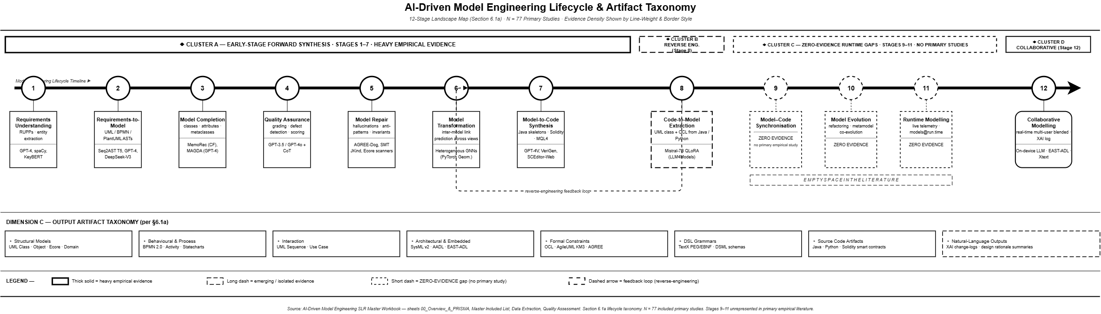
SECTION 7: REFERENCES (APA 7th Edition)
Ahmed, A., et al. (2026). VeriGen: An LLM-augmented framework for end-to-end automation of software development lifecycle—From requirements specifications to code generation. IEEE Access, 14, 36860–36880. https://doi.org/10.1109/ACCESS.2026.3686308
Ait Hsain, Y., et al. (2025). SCEditor-Web: Bridging model-driven engineering and generative AI for smart contract development. Information, 16(10), 870. https://doi.org/10.3390/info16100870
Alaswad, F., et al. (2026). GenClass: Sequence-to-AST neural machine translation for UML class diagram generation. Machine Learning with Applications, 100940. https://doi.org/10.1016/j.mlwa.2026.100940
Antal, G., Vozár, R., & Ferenc, R. (2024). Assessing GPT-4-Vision's capabilities in UML-based code generation. In Proceedings of the 2024 IEEE/ACM International Conference on Software Engineering: Companion Proceedings (ICSE-Companion '24) (pp. 253–256). ACM. https://doi.org/10.1145/3643795.3648391
Awan, M., et al. (2026). AI-augmented real-time collaborative blended modeling framework for automotive embedded systems. IET Software, 2026(1), Article 6696040. https://doi.org/10.1049/sfw2/6696040
Ben Chaaben, M., Burgueño, L., David, I., & Sahraoui, H. (2026). On the utility of domain modeling assistance with large language models. ACM Transactions on Software Engineering and Methodology (TOSEM), 35(4), Article 112. https://doi.org/10.1145/3744920
Boujmil, I., & Chebil, W. (2025). Improving BPMN model generation from texts through a prompt-guided fusion of NLP and LLM approaches. In Proceedings of the 13th Knowledge Capture Conference (K-CAP '25) (pp. 1–5). ACM. https://doi.org/10.1145/3731443.3771362
Chen, K., Yang, Y., Chen, B., López, J. A. H., Mussbacher, G., & Varró, D. (2023). Automated domain modeling with large language models: A comparative study. In Proceedings of the 26th ACM/IEEE International Conference on Model Driven Engineering Languages and Systems (MODELS '23) (pp. 162–172). IEEE. https://doi.org/10.1109/MODELS58315.2023.00037
Chen, R., Shen, J., & He, X. (2026). MoRe: LLM-based domain model generation with hybrid self-refinement. Electronics (Switzerland), 15(6), Article 1239. https://doi.org/10.3390/electronics15061239
De Bari, D., Garaccione, G., Coppola, R., Torchiano, M., & Ardito, L. (2024). Evaluating large language models in exercises of UML class diagram modeling. In Proceedings of the 18th ACM/IEEE International Symposium on Empirical Software Engineering and Measurement (ESEM '24) (pp. 101–112). ACM. https://doi.org/10.1145/3674805.3690741
Delgado, D., et al. (2026). A modular framework for assessing the capabilities of code generation of constraint domain-specific languages with large language models. Journal of Systems and Software, 238, Article 112871. https://doi.org/10.1016/j.jss.2026.112871
Di Rocco, J., Di Ruscio, D., Di Sipio, C., Nguyen, P. T., & Pierantonio, A. (2023). MemoRec: A recommender system for assisting modelers in specifying metamodels. Software and Systems Modeling, 22(3), 994–1012. https://doi.org/10.1007/s10270-022-00994-2
Karlsson Landgren, A., Johnsen, P. P., & Strüber, D. (2025). Cross-platform edge deployment of machine learning models: A model-driven approach. Software and Systems Modeling, 24(2), 1273–1290. https://doi.org/10.1007/s10270-025-01273-6
Miranda, J. P., Bruneliere, H., Tisi, M., & Sunye, G. (2024). Towards the integration support for machine learning of inter-model relations in model views. In Proceedings of the 39th ACM/SIGAPP Symposium on Applied Computing (SAC '24) (pp. 360–368). ACM. https://doi.org/10.1145/3605098.3636143
Morales, S., Clarisó, R., & Cabot, J. (2025). Impromptu: A framework for model-driven prompt engineering. Software and Systems Modeling, 24(4), 1627–1645. https://doi.org/10.1007/s10270-024-01235-4
Siala, H. A. (2024). Enhancing model-driven reverse engineering using machine learning. In Proceedings of the 46th International Conference on Software Engineering: Companion Proceedings (ICSE-Companion '24) (pp. 46–50). ACM. https://doi.org/10.1145/3639478.3639797
Siala, H. A., & Lano, K. (2025). Using large language models to extract UML class diagrams from Java programs. In Proceedings of the 2025 IEEE International Conference on Software Science and Engineering (ICoSSE '25) (pp. 20–27). IEEE. https://doi.org/10.1109/ICoSSE65712.2025.00020
Siala, H. A., & Lano, K. (2026). Leveraging LLMs for abstracting UML and OCL representations from Java and Python programs. Journal of Systems and Software, 238, Article 112874. https://doi.org/10.1016/j.jss.2026.112874
Tahat, A., Amundson, I., Hardin, D., & Cofer, D. (2026). AGREE-Dog Copilot: A neuro-symbolic approach to enhanced model-based systems engineering. In B. Steffen (Ed.), Bridging the Gap Between AI and Reality (AISoLA 2025, LNCS Vol. 16220, pp. 112–131). Springer. https://doi.org/10.1007/978-3-032-07132-3_8
Tsampouris, G., et al. (2025). RQ2DSL: An AI agent for automated domain-specific language grammar generation from requirements. In Proceedings of the 37th IEEE International Conference on Tools with Artificial Intelligence (ICTAI '25) (pp. 189–196). IEEE. https://doi.org/10.1109/ICTAI66417.2025.00189
Wang, C., Wang, B., Liang, P., & Liang, J. (2024). Assessing UML diagrams by GPT: Implications for education. Applied Sciences (Switzerland), 14(23), Article 10873. https://doi.org/10.3390/app142310873

